AUTONOMOUS POWER ROUTING IN STOCHASTIC SMART GRIDS: A COMPARATIVE STUDY OF CENTRALIZED
TRANSFORMER-DQN AND DECENTRALIZED CONTINUOUS MARL
Vatsal, Samarth, Krish, Garv
Department of Computer Science and Engineering, Manipal University Jaipur, Jaipur, India
PBL Mentors / Guides: Aprna Tripathi and Jashwant

Abstract— Modern power systems are becoming harder to balance because electricity generation and demand no longer behave like slowly changing, predictable quantities. Solar and wind output can shift with weather, industrial demand can jump unexpectedly, and transmission constraints can turn a locally sensible decision into a network-wide problem. This paper studies autonomous power routing in a controlled stochastic smart-grid simulator and compares two learning-oriented designs: a centralized Transformer-based Deep Q-Network (Transformer-DQN) with seven discrete 20 MW routing actions, and a decentralized graph-based multi-agent reinforcement-learning (MARL) controller with continuous substation set-points. The simulator combines diurnal profiles, Markov weather regimes, autocorrelated disturbances, stochastic events, DC power flow, transmission impedance, I²R losses, thermal limits, actuator slew-rate and response dynamics, and N−1 line contingencies. An LSTM forecaster is first used to provide a temporal baseline and achieves a held-out RMSE of 7.54 MW, compared with 9.57 MW for persistence. In the completed centralized evaluation over 240 unseen hours, Transformer-DQN reduces aggregate imbalance by 23.62%, compared with 24.38% for a one-step greedy oracle and 22.00% for the TransferAgent. The decentralized implementation is validated at the environment and training-infrastructure level, including graph-topology changes and safety-cost pathways, but its final multi-seed PPO/CPO evaluation was not completed in the available run. Accordingly, this paper expands and interprets the completed evidence without presenting unfinished decentralized training as a final performance result.
Index Terms— Smart Grid, Reinforcement Learning, Deep Q-Network, Transformer, Multi-Agent Reinforcement Learning, Graph Neural
Network, PPO, CPO, Power Routing

INTRODUCTION
Electric power systems are increasingly being operated under conditions that are difficult to describe with a single predictable operating point. Renewable generation introduces weather dependence, distributed resources create more geographically dispersed injections and withdrawals, and demand can change sharply when industrial or commercial loads react to external conditions. In such a setting, a controller must repeatedly answer a practical question: where should available power be routed next, and by how much? The difficulty is that the answer depends not only on the current imbalance but also on recent history, network connectivity, physical losses, and the possibility that part of the grid may become unavailable.
Reinforcement learning (RL) is attractive for this class of problem because it treats control as sequential decision-making. An agent observes the system, takes an action, receives feedback, and updates its policy or value estimate. Unlike a static regression model, an RL controller is therefore evaluated through the consequences of its actions. In power-system control, this distinction matters: an action that reduces imbalance at one node can increase losses, overload another corridor, or become ineffective after a line outage.
This study focuses on two complementary ways of representing the control problem. The first is centralized: one controller sees the complete grid state and chooses one of seven discrete routing actions. A Transformer encoder is used to summarize a six-step temporal observation window before the DQN estimates the value of each action. The second is decentralized: each substation acts as an agent, observes node-level features and the current network topology, and produces a continuous command. A graph neural network (GNN) is used because the physical grid is naturally represented as a graph, while PPO and CPO provide unconstrained and safety-constrained policy-optimization pathways.
The purpose of the comparison is not to claim that one learning paradigm is universally superior. The two implementations intentionally differ in action representation, observation structure, physical interface, and learning algorithm. Instead, the study asks what happens when temporal attention, graph-based coordination, continuous actuation, and safety constraints are introduced into the same stochastic grid-control setting. This distinction is important because a performance difference can arise from several architectural choices at once.
The paper therefore makes four research questions explicit: RQ1 asks how well centralized Transformer-DQN reduces imbalance under stochastic conditions; RQ2 examines the behavior of graph-based decentralized continuous control on a shared physical grid; RQ3 asks whether an explicit safety-cost pathway can provide guardrails for decentralized learning; and RQ4 examines whether the graph-based controller can be transferred to a larger topology without changing its core environment, agent, or trainer classes.
The main contributions are a controlled stochastic grid environment, a physics-consistent centralized benchmark, a graph-based continuous-control implementation with safety-cost estimation, and an experimental harness intended for multi-seed comparison. The current draft reports only results that were completed and directly verifiable in the available notebook.
Fig. 1. Conceptual three-node stochastic grid used by the study.
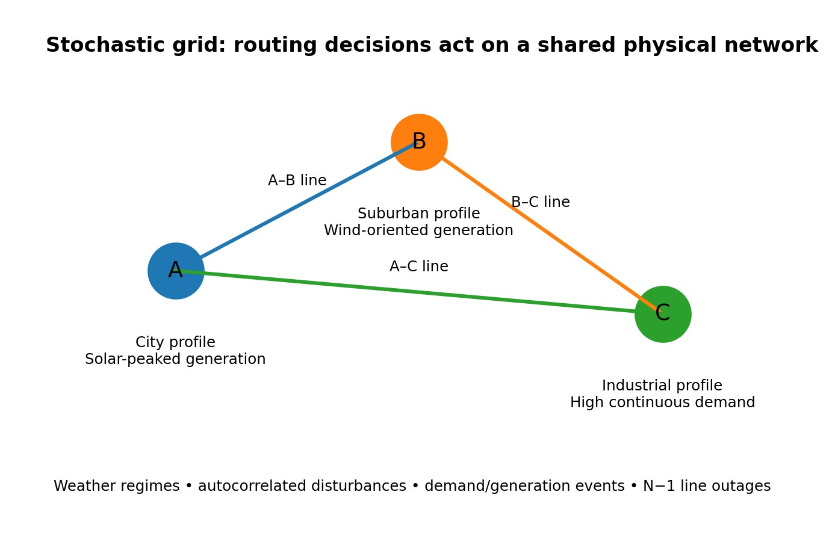
The original draft defines Node A as a city profile with solar-peaked generation, Node B as a suburban profile with wind-oriented generation, and Node C as an industrial profile with comparatively high continuous demand. This topology is deliberately small enough to make the experimental mechanics easy to inspect while still allowing interactions among generation, demand, routing, and outages.

II. SYSTEM MODEL AND PROBLEM FORMULATION

A. From Power Balance to a Learning Problem
At each hour, every node has a generation value G (t) and a load x
value L (t). The local net imbalance is defined as the difference x
between generation and load. Positive imbalance indicates surplus generation, whereas negative imbalance indicates a local shortfall. The controller attempts to reduce the absolute imbalance across all nodes rather than optimizing one node in isolation.
For the three-node system, the aggregate stress measure used in the reported evaluation can be written as:
S = Σ |Imb | i i
A routing action changes the physical distribution of power and therefore changes S. The centralized reward compares pre-action and post-action aggregate imbalance and subtracts a loss-related penalty:
R = [Σ |Imb pre| − Σ |Imb ^{post}| − c L ] / 10 t i i i i loss t
This formulation captures an important practical trade-off. A controller should not receive the same credit for two actions that reduce imbalance by the same amount if one action creates substantially more transmission loss. In other words, imbalance reduction is the main task objective, while loss acts as a secondary physical cost.

B. Why the Environment Is Stochastic
The environment is intentionally non-stationary. A daily Markov weather regime can switch between Normal, Heatwave, and Storm conditions, while an autoregressive process creates temporal correlation in forecast-like errors. Rare events are then superimposed on the ordinary patterns. This combination is useful because a controller that only memorizes the average daily curve would be exposed to a different operating condition whenever a regime or anomaly changes.
The stochastic design also creates a meaningful role for memory. If the current imbalance is partly explained by recent weather or demand behavior, then the previous few observations contain information about what is likely to happen next. This is the motivation for both the LSTM forecasting stage and the Transformer temporal encoder.

C. Physical Constraints
The routing problem is constrained by the physical network. The current implementation uses DC power flow with line impedance and includes I²R losses and thermal limits. The decentralized environment additionally tracks a voltage estimate, hardware set-points, slew-rate limits, actuator response, and N−1 line contingencies. These details prevent the learning agents from treating power transfers as instantaneous bookkeeping operations.

III. STOCHASTIC DATA GENERATION AND EXPLORATORY ANALYSIS
A controlled synthetic generator is used so that the same stochastic assumptions can be reproduced across experiments. This is particularly useful for an academic prototype because the researchers can deliberately expose the controller to disturbances while retaining knowledge of how the data were produced. The trade-off is that synthetic data cannot fully represent the complexity of an actual transmission operator's data stream. A. Diurnal Profiles and Weather Regimes
The base load and generation series use phase-shifted sinusoidal functions. For Node A, the draft defines:
L (t) = 50 + 20 sin[(2π/24)(t − 14)]
A,base
G (t) = 40 + 35 sin[(2π/24)(t − 6)]
A,base
The phase difference means generation and demand do not peak at exactly the same time. This creates a natural reason for routing: even when total daily energy is adequate, the spatial and temporal mismatch between supply and demand can produce local imbalance.
The weather regime S ∈ {Normal, Heatwave, Storm} follows the transition matrix reported in the original draft:
P = [[0.85, 0.10, 0.05], [0.20, 0.80, 0.00], [0.30, 0.00, 0.70]]
The matrix introduces persistence, meaning that the current regime is more likely to continue than to change at every step. This makes the environment different from independent random noise and gives temporal models an opportunity to exploit regime information.
B. Autocorrelated Noise and Rare Events Forecast-error-like variation follows an AR(1) process, ε = t
0.85ε + N(0, σ). The coefficient of 0.85 produces strong t−1
short-term persistence: a disturbance today tends to influence the next few observations rather than disappearing immediately. In addition, Node C can experience a 30–60 MW industrial demand spike with probability 0.02, Node A can experience a solar blockout with probability 0.005, and Node B can experience a 20% load reduction with probability 0.01.

C. Exploratory Statistics
The original 30-day exploratory sample contains 720 hourly observations. The mean absolute imbalance across the grid is reported as 75.61 MW. Node A and Node B show a negative Pearson correlation of −0.294, suggesting that their imbalance patterns can partially compensate for one another. Node B and Node C show a positive correlation of +0.452, meaning their imbalances can deteriorate together. Because the generated series are temporally autocorrelated, the original t-tests should be treated as exploratory rather than as fully independent-sample inference.
The draft also reports different imbalance variances across weather regimes using a Levene test. Taken together, these observations motivate a controller that can adapt to both predictable daily structure and changing operating regimes.

IV. SUPERVISED TEMPORAL FORECASTING
Before reinforcement learning, the study trains an LSTM to predict next-hour net imbalance from a six-hour lookback window. The input therefore has shape 6 × 3, representing six time steps across the three nodes. Values are normalized using IMB_SCALE = 100. The network contains a 32-unit LSTM, a 16-unit ReLU feature extractor, and a three-unit linear output layer. Training uses Adam with a learning rate of 0.001 for 30 epochs and an 80/20 chronological split.
The forecasting stage has two roles. First, it provides a measurable check that temporal structure exists in the generated data. Second, its learned feature extractor is reused by the TransferAgent, creating an architectural baseline against which the Transformer-based state representation can be compared. This is a useful design because it asks whether a more specialized attention mechanism provides value beyond a compact recurrent representation.
Metric | LSTM | Persistence
MAE (MW) | 4.995 | 6.850
RMSE (MW) | 7.54 | 9.57
R² | 0.911 | 0.856
RMSE reduction | 21.2% | —
Table I. Held-out forecasting performance reported in the draft.
The held-out LSTM run reports MAE = 4.995 MW, RMSE = 7.54 MW, and R² = 0.911, while persistence gives MAE = 6.850 MW, RMSE = 9.57 MW, and R² = 0.856. The reported 21.2% RMSE reduction indicates that the forecasting model captures useful temporal structure. It does not, by itself, establish that the forecasting model improves the final control policy; that causal connection would require a dedicated ablation.

V. CENTRALIZED TRANSFORMER-DQN CONTROL

A. Action Space
The centralized controller has seven discrete actions: Hold, A→B, B→C, C→A, B→A, C→B, and A→C. Every transfer represents a 20 MW routing block. This makes the action space small enough for a DQN to enumerate the available alternatives at each decision step. The limitation is equally clear: a 20 MW action grid cannot express a fine-grained 7 MW or 13 MW correction.

B. Temporal State Representation
At every decision, the controller receives a six-step temporal window containing the complete three-node state. The input is projected into a learned representation and combined with a one-dimensional positional embedding. Four attention heads then process the sequence, with d = 32. Global pooling produces the key
representation supplied to the Q-network.
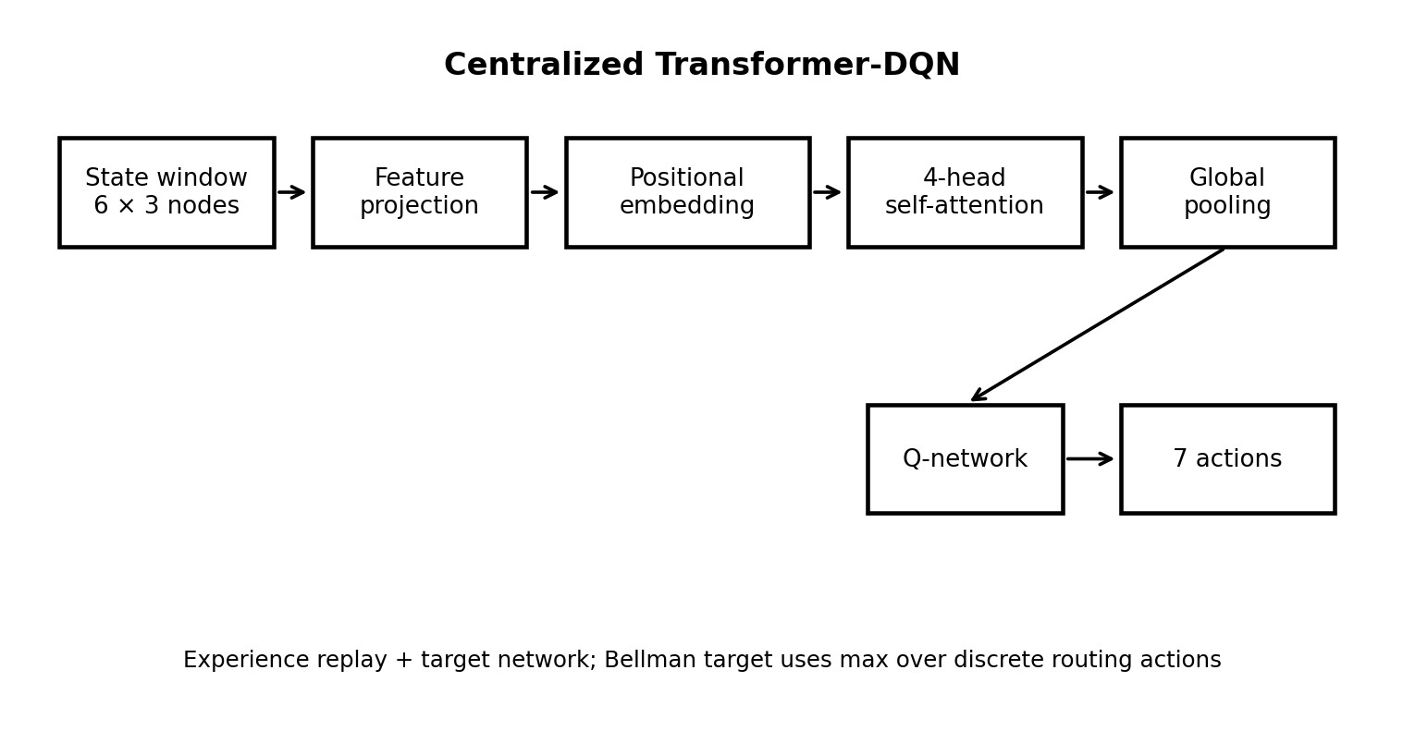
Fig. 2. Simplified Transformer-DQN architecture used in the centralized design.
Self-attention is useful here because the importance of an earlier observation is not necessarily fixed. For example, a sudden demand change two or three hours earlier may matter more than a routine observation immediately preceding the current action. The Transformer can learn such relationships directly from the temporal sequence.

C. DQN Learning Target
The learning target is the standard one-step bootstrapped form used in the draft:
Y = R + γ max Q (S , a′) t t a′ θtarget t+1
Experience replay reduces the correlation between consecutive training samples, while a separate target network stabilizes the bootstrapped target. Together, these mechanisms are especially relevant in a stochastic environment because the controller is already learning from transitions whose dynamics are noisy and regime-dependent.

D. TransferAgent Baseline
The TransferAgent replaces the Transformer state encoder with the frozen feature extractor from the pre-trained LSTM while keeping the downstream Q-learning framework. This isolates one architectural question: whether the representation learned for next-hour forecasting can support routing decisions nearly as well as a representation learned directly through the control objective.

VI. DECENTRALIZED GRAPH-BASED CONTINUOUS CONTROL
A. Why a Graph Representation?
A power grid is not simply a list of independent substations. Each node is connected to other nodes, and the consequences of an action depend on those connections. A graph representation therefore provides a natural interface between the learning system and the physical network. In the current implementation, every agent receives node features together with the live N × N adjacency matrix and a one-hot identifier for its own node.
Two rounds of dynamic graph convolution allow information to pass through neighboring nodes. This becomes especially important during a line outage: when an A–B connection is removed, the adjacency matrix changes, and the same controller architecture can process the altered topology without requiring a separately trained network for that exact graph.

B. Continuous Actuation and Hardware Dynamics
Unlike the centralized controller, each decentralized agent produces a continuous normalized command in [−1, 1], corresponding to a hardware command of up to ±50 MW. The environment imposes a 15 MW-per-step slew-rate limit and a first-order response coefficient of 0.5. These restrictions are important because a real actuator cannot normally jump from zero to its maximum output instantaneously. The simulated response therefore introduces a small but meaningful gap between what the policy requests and what the physical environment applies.

C. Observation Design
Each node contributes six features: imbalance, reactive load, voltage estimate, applied hardware set-point, next-hour forecast, and normalized hour. The observation also contains the live adjacency matrix and a one-hot node identifier. For the three-node environment, the resulting observation dimension is 30. The design intentionally combines local operating information with enough topology information for the agent to reason about its position within the shared network.

D. PPO and CPO
The decentralized training harness supports both PPO and Constrained Policy Optimization (CPO). PPO provides the unconstrained policy-learning baseline, while CPO adds an explicit safety-cost pathway. The same GNN architecture, data and training budget are intended to be shared so that the main algorithmic difference is the policy-update mechanism.
CPO uses a cost-value head together with a diagonal empirical Fisher approximation and backtracking line search. An update is accepted only when the relevant surrogate-improvement, KL-change, and estimated safety-cost checks are satisfied.
Generalized Advantage Estimation is used for policy learning:
Â = Σ ∞(γλ)^{l}δ^{V}
t l=0 t+l

VII. PHYSICS-RESOLVED ENVIRONMENT
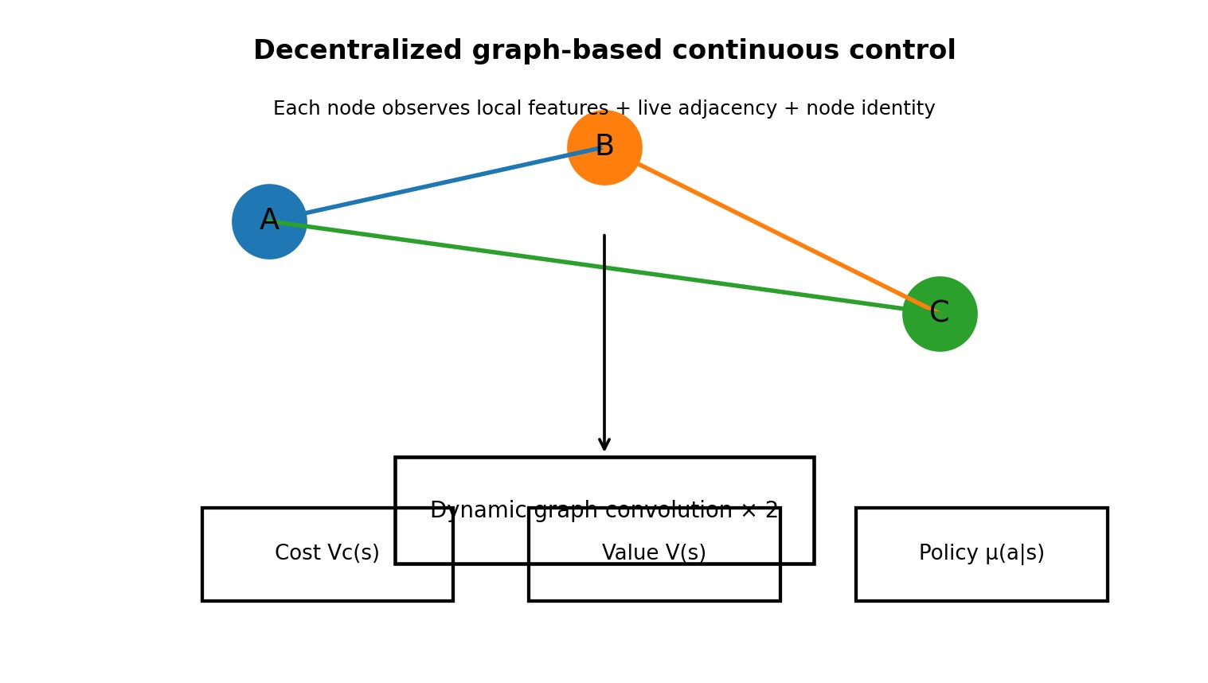
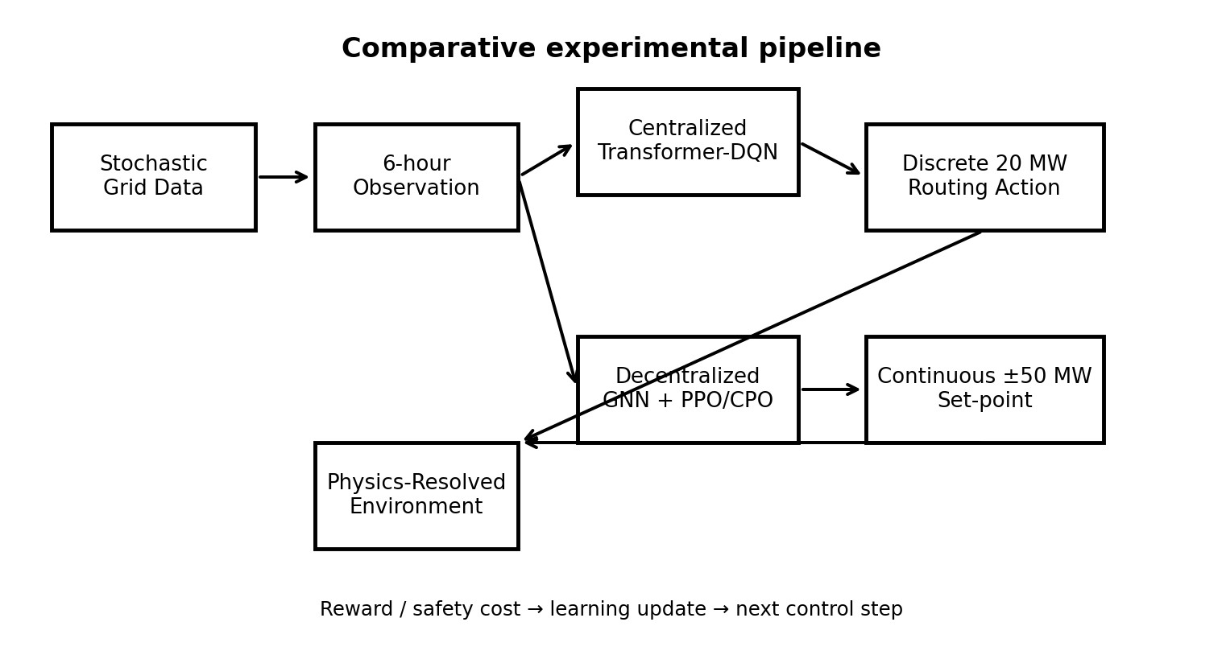
A useful feature of the updated implementation is that the learning algorithm does not operate on an abstract transfer table alone. The physical environment resolves power transfers through a DC power-flow model over available lines. Transmission impedance and I²R losses are included, along with thermal limits and a voltage estimate. The decentralized environment additionally models stochastic N−1 line contingencies.
Fig. 3. Graph-based decentralized controller with separate policy, value, and
cost-value pathways.
This matters for interpreting the results. If a controller learns
only from a bookkeeping equation, it may discover that sending
power from one node to another always has a predictable effect. In
the physics-resolved environment, that effect depends on the
active topology and the resulting network flow. A line outage can
therefore change which actions are useful, and losses can make
two imbalance-equivalent actions physically different.
Fig. 4. End-to-end experimental pipeline.

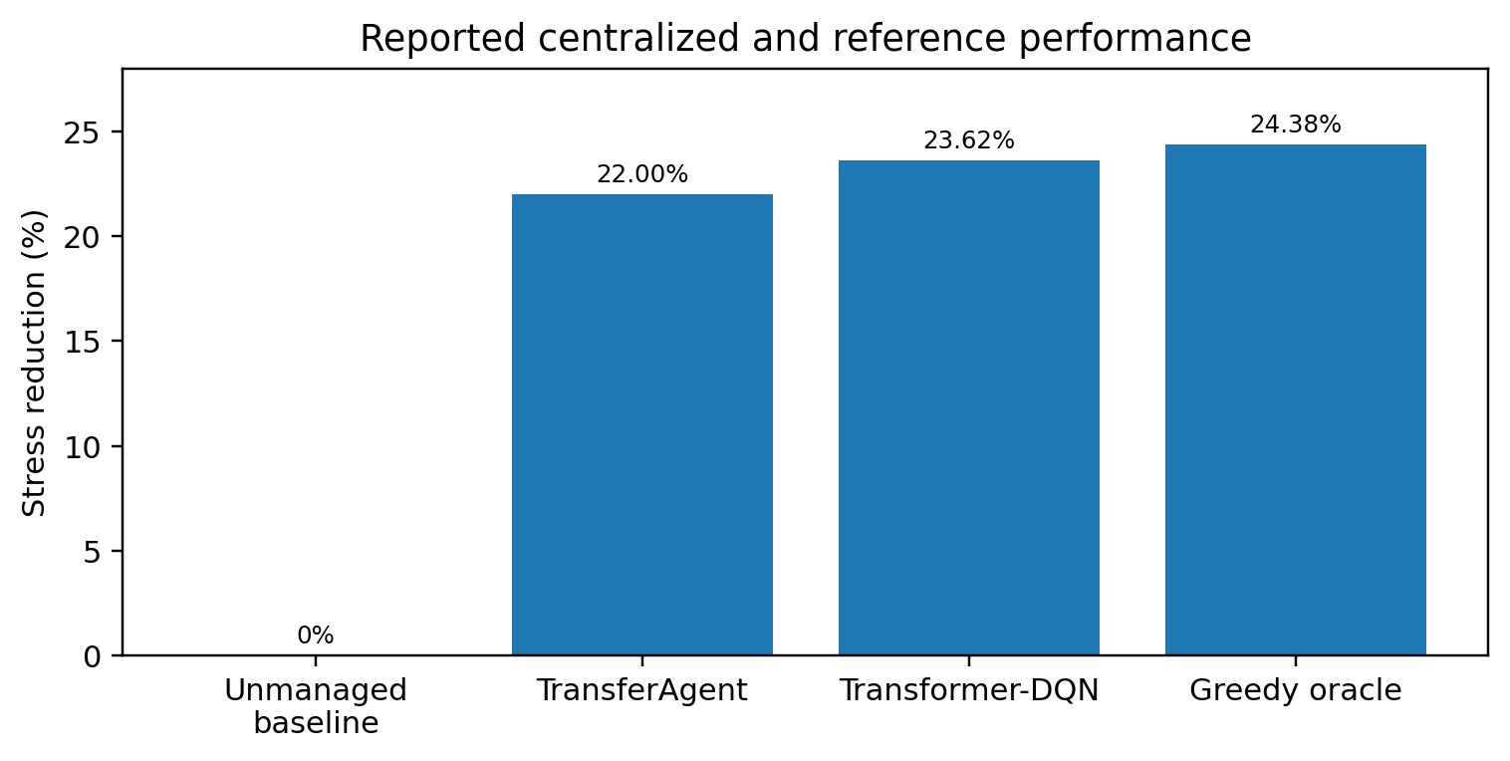
The smoke tests reported in the draft verify three important pathways: the continuous environment exposes three agents with 30-dimensional observations; a +50 MW command is initially applied as 7.5 MW because of the 15 MW/step slew constraint and then increases over subsequent steps; and an A–B line trip changes the adjacency matrix supplied to the graph controller. These checks establish that the intended environment mechanics are connected to the agent interface.

VIII. EXPERIMENTAL DESIGN
The centralized experiments use the configurations described in the notebook and evaluate policies over a 240-hour unseen test Fig. 5. Reported stress-reduction results for the completed centralized window. The decentralized benchmark is configured for five evaluation. evaluation seeds and 150 training episodes per seed. The available
The centralized action-selection analysis also requires care. The
run completed the five CPO training seeds, but it did not complete greedy oracle has an imbalanced label distribution, with Hold as
the final PPO/CPO evaluation and aggregation cells. This the majority action at 39.1%. For that reason, simple agreement
distinction is retained throughout the paper because reporting should not be interpreted in isolation. The draft reports 59.8%
incomplete evaluations as final performance would make the oracle agreement and Cohen's κ = 0.488, indicating non-trivial
comparison misleading. agreement beyond class frequency. The evaluation also reports
The experimental workflow can be summarized as: (1) generate 100% agreement between the greedy-oracle implementation and stochastic grid trajectories; (2) split training and evaluation periods the environment's physics calculation, supporting the internal chronologically where applicable; (3) train the LSTM forecaster; consistency of the oracle-label generation pathway.
(4) train the centralized DQN family; (5) evaluate against the _{C. Efficiency Trade-off} physics-consistent greedy oracle; (6) validate the decentralized
Controller | Stress reduction | I²R loss | Thermal/voltage violatio
No control | 0.00% | 0.00 MW | None
Proportional reference | 21.24% | 1.32 MW | 0.0%
Component | Configuration
Grid | 3 nodes; synthetic stochastic time series
Temporal window | 6 hours
Centralized actions | 7 actions × 20 MW
Continuous command | ±50 MW; 15 MW/step slew limit
Forecast model | LSTM: 32 + 16 units; 30 epochs
Centralized test | 240 unseen hours
Decentralized training | 5 CPO seeds × 150 episodes
Decentralized evaluation | Not completed in available run
environment and safety pathways; and (7) complete multi-seed The main centralized result is not simply that the learned PPO/CPO evaluation before drawing a final decentralized controller reduces imbalance. The draft also reports that performance comparison. Transformer-DQN uses more active routing and produces higher measured I²R losses than the oracle. Its measured loss is 14.77 MW and its active-hour rate is 93.33%. This shows why a single performance number is insufficient: the controller can be close to the oracle in imbalance reduction while still making more frequent or physically expensive routing decisions.

X. DECENTRALIZED VALIDATION AND ERROR ANALYSIS
The decentralized implementation is currently best interpreted as an infrastructure and feasibility result rather than as a completed head-to-head performance result. The smoke tests verify that the graph observations, continuous actions, actuator dynamics, and
Table II. Experimental configuration preserved from the available draft. topology changes are connected correctly. The five CPO training seeds were executed for 150 episodes each, and the logged
IX. RESULTS AND PERFORMANCE ANALYSIS checkpoints reported zero safety cost and zero thermal/voltage
_{A. Forecasting Result} violations. However, because the final PPO/CPO evaluation and
aggregation cells were not completed, these diagnostics cannot be The LSTM forecaster provides a useful preliminary result. Its used to claim that CPO outperforms PPO or any other controller. held-out R² of 0.911 and RMSE of 7.54 MW show that the synthetic environment contains predictable temporal structure. The The reference-controller sanity checks are more concrete. Over persistence baseline is weaker, with RMSE 9.57 MW. The 21.2% 48 unseen hours, the no-control policy produces 0.00% stress reduction in RMSE is therefore evidence that the learned temporal reduction, 0.00 MW I²R losses, and no thermal/voltage violations. model captures information beyond simply repeating the previous The proportional reference produces 21.24% stress reduction, 1.32 observation. MW I²R losses, and 0.0% thermal/voltage violations. These checks are useful because they demonstrate that the evaluation pipeline ^{B. Centralized Control Result} can distinguish an inactive controller from a simple active
The centralized evaluation is the most complete part of the reference while simultaneously tracking physical costs.
current study. Across the 240-hour unseen test window, all policies share the same unmanaged baseline of 16,303.73 MW aggregate imbalance. Transformer-DQN reduces this to 12,452.91 MW, corresponding to a 23.62% stress reduction. The TransferAgent reaches 22.00%, while the one-step greedy oracle reaches 24.38%. Table III. Completed 48-hour decentralized/reference sanity checks.
The Transformer-DQN therefore achieves 23.62/24.38 × 100 ≈
96.9% of the oracle's observed stress reduction. This is an A key methodological point is that the centralized and oracle-relative comparison, not a proof of global optimality. decentralized designs are not a controlled algorithm-only comparison. The centralized agent uses seven discrete 20 MW actions and global state, whereas the decentralized system uses continuous ±50 MW hardware set-points, local observations, graph communication, actuator dynamics, and a different

optimization family. Consequently, the paper treats them as two evaluated system designs rather than as an experiment that isolates the causal effect of centralization alone.

XI. DISCUSSION
The completed evidence suggests that temporal representation is valuable in this stochastic control setting. The LSTM can forecast next-hour imbalance substantially better than persistence, and the Transformer-DQN subsequently uses a six-step state history to choose routing actions. The centralized controller reaches an imbalance reduction close to the one-step greedy oracle, which indicates that a learned policy can recover much of the useful structure contained in a direct model-based action evaluation.
At the same time, the loss and activity statistics reveal a less obvious issue: reducing imbalance is not the same as optimizing the entire physical operating objective. A controller may act more frequently because it is trying to correct small deviations, and those additional transfers can introduce transmission losses. A future reward design could therefore examine explicit multi-objective trade-offs among imbalance, losses, switching frequency, and constraint margins.
The decentralized architecture addresses a different problem. A central controller has access to a complete state and can directly compare global alternatives, but its state and action representations become more cumbersome as the network grows. Graph-based agents instead exploit locality and shared topology information. The expected advantage is structural: the same message-passing mechanism can potentially operate on graphs with different connectivity patterns. However, the present three-node implementation is not sufficient to establish scalability; that question remains an explicit future experiment.
Safety constraints are similarly promising but not yet empirically settled by the current run. CPO introduces a cost-value head and a policy-update rule that explicitly checks estimated safety cost. This is conceptually different from merely adding a large penalty to the reward: the safety signal is maintained as a separate quantity during policy optimization. Whether that design produces better final control performance requires the missing multi-seed PPO/CPO evaluation.
Error analysis also points to a broader lesson. Because the simulator is stochastic and the decentralized controller is multi-agent, performance should ultimately be reported as distributions across seeds rather than as a single training run. Confidence intervals or mean ± standard deviation would make it possible to distinguish consistent improvements from variability caused by random initialization, exploration, and disturbance realization.

XII. LIMITATIONS
First, the data are synthetic. The generator is valuable for controlled experimentation, but real power systems contain measurement error, communication delays, market interactions, protection logic, generator ramp constraints, topology complexity, and operational procedures that are not fully represented here.
Second, the physical model uses DC power flow rather than a full AC Newton–Raphson solution. Voltage and reactive-power behavior are therefore approximations. The three-node network is also intentionally small, so it should not be interpreted as a realistic transmission-system model.
Third, the action spaces differ between the two controllers. The centralized system chooses discrete 20 MW blocks, while the decentralized system produces continuous ±50 MW commands subject to hardware dynamics. This difference is useful for studying the two architectures, but it prevents a perfectly controlled comparison of only the learning algorithm.
Fourth, the current run does not contain the final PPO/CPO multi-seed evaluation aggregate or the completed five-node scalability experiment. These missing experiments are not filled in here. Before publication, the study should complete the planned evaluations, report uncertainty estimates, and add ablations that separately isolate reward design, graph communication, observation structure, and safety constraints.

XIII. FUTURE WORK
The next experimental step should be a completed multi-seed comparison of PPO and CPO under identical disturbance realizations where possible. The study should report mean ± standard deviation for imbalance reduction, I²R losses, active routing, thermal violations, voltage violations, and safety cost. Statistical tests should be selected with attention to the temporal dependence of the trajectories rather than treating every hourly observation as an independent sample.
A second step is a controlled ablation study. One experiment can remove temporal attention while keeping the rest of the Transformer-DQN pipeline fixed. Another can remove graph communication, forcing each decentralized agent to rely only on local information. A third can disable the explicit safety constraint. Together, these experiments would make it possible to attribute observed changes to specific design components rather than to the overall system architecture.
A third direction is topology scaling. The five-node experiment already identified in the draft should be completed and reported separately from the three-node benchmark. Beyond that, the controller should be evaluated on standard IEEE test systems. Such experiments would provide a more recognizable reference point for the power-systems community and would make scalability claims more meaningful.
Finally, a stronger physics layer should be considered. Replacing the DC approximation with full AC power flow would allow voltage magnitude, reactive power, and line-flow constraints to be treated more faithfully. Realistic communication and actuator delays could then be added to test whether the learned policy remains stable when observations and control commands are not perfectly synchronized.

XIV. CONCLUSION
This expanded study presents autonomous power routing as a sequential control problem in which uncertainty, temporal dependence, network topology, and physical constraints interact. The centralized Transformer-DQN uses a six-step global state history and seven discrete routing actions, while the decentralized design uses graph-based message passing and continuous hardware set-points. Both are evaluated within a stochastic environment designed to expose controllers to weather regimes, autocorrelated disturbances, rare events, transmission losses, thermal limits, actuator dynamics, and line contingencies.
The completed centralized results provide the clearest empirical finding in the current draft: over 240 unseen hours, Transformer-DQN reduces aggregate imbalance by 23.62%, compared with 24.38% for the one-step greedy oracle and 22.00% for the TransferAgent. The result is encouraging in the narrow sense that the learned controller approaches the observed oracle reduction, but it also comes with higher activity and measured I²R loss. The paper therefore treats imbalance reduction and routing efficiency as related but distinct objectives.
The decentralized implementation has reached a validated experimental foundation rather than a completed performance comparison. Its graph observations, continuous action interface, actuator response, safety-cost pathway, and topology-change handling have been checked. The proportional reference achieves 21.24% stress reduction over 48 unseen hours, while the no-control reference establishes the expected 0.00% reduction. The final PPO/CPO evaluation remains necessary before drawing performance conclusions about constrained versus unconstrained decentralized learning.
Overall, the study provides a reproducible framework for examining how temporal attention and graph-based decentralized control behave when reinforcement learning is coupled to a stochastic, physics-resolved grid. Completing the planned multi-seed evaluation, ablations, topology scaling, and higher-fidelity power-flow validation would be the natural path from this controlled research prototype toward stronger publication-level evidence.

REFERENCES
- D. Wang, D. Zhao, X. Liu, et al., “MARS-RA: Rank Aggregation forCredit Assignment via Multimodal Comparisons in Embodied Multi-Agent Cooperation,” arXiv preprint arXiv:2607.27967, 2026.
- M. Alqahtani and M. Hu, “Reinforcement Learning for Fair and EfficientCharging Coordination for Smart Grid,” Energies, vol. 17, no. 18, p. 4557, 2024.
- M. Preller and J. Schmutzler, “Knowledge Distillation for Efficient
Transformer-Based Reinforcement Learning in Hardware-Constrained Energy Management Systems,” arXiv preprint arXiv:2603.26249, 2026.
- J. Kim and G. B. Giannakis, “Real-time coordination of distributedenergy resources using multi-agent reinforcement learning,” IEEE Transactions on Smart Grid, vol. 13, no. 1, pp. 159–171, 2022.
- J. Achiam, D. Held, A. Tamar, and P. Abbeel, “Constrained PolicyOptimization,” in Proc. ICML, 2017.
- A. Vaswani, N. Shazeer, N. Parmar, et al., “Attention Is All You Need,”in Advances in Neural Information Processing Systems, 2017.
- T. N. Kipf and M. Welling, “Semi-Supervised Classification with GraphConvolutional Networks,” in International Conference on Learning Representations, 2017.
- J. Schulman, F. Wolski, P. Dhariwal, A. Radford, and O. Klimov,“Proximal Policy Optimization Algorithms,” arXiv:1707.06347, 2017.
- R. S. Sutton and A. G. Barto, Reinforcement Learning: An Introduction, 2nd ed., MIT Press, 2018.
Source note: The empirical values and implementation-status statements in this expanded paper are derived from the supplied draft. Conceptual explanations and standard background references were added to improve readability and academic completeness; no unfinished PPO/CPO performance result has been presented as a completed result.

